

Asset Practice Questions: Science

**1. A group of students wish to measure the height of a plant. Which of these will help them measure it?**

**A.** a weighing balance

**B.** a thermometer

**C.** a ruler

**D.** a lens

**2. How old may the oldest person in the world be?**

**A.** 50 years

**B.** 80 years

**C.** 110 years **D.** 250 years

**3. Which of these is nearest to us?**

**A.** the sun

**B.** the moon

**C.** the moving clouds

**D.** a flying crow

**4. Which of these hands moves the FASTEST in a clock?**

**A.** the hour hand

**B.** the minute hand

**C.** the second hand

**D.** all move at the same speed

**5. Before eating food, we must wash our hands with soap and water so that .**

**A.** our hands become nice and soft

**B.** the food we eat becomes fresh and healthy

**C.** the germs present in the water are washed away

**D.** the germs present on our hands are washed away

**6. The road is marked in many ways to tell us different things. Which of the figures given below shows a**

**ZEBRA CROSSING and tells us where to cross the road?**

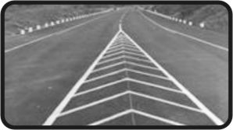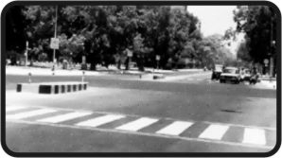**A. 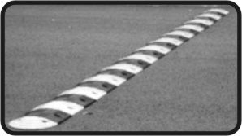 B.** 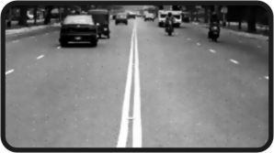

**C. D.**

**7. In India, which of these can be seen ONLY in a Zoo?**

**A. 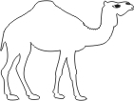 B.** 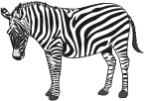

**C. 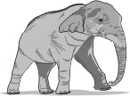 D.** 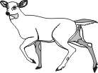

**8. Which of these signs is MOST COMMONLY seen in front of a hospital?**

**A. 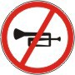 B. **

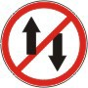

**C. D.**

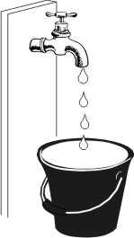**9. A tap in Vishnu's house was leaking slowly. So he kept an empty bucket under it.**

**In how much time might the bucket get completely filled? A.** 5 seconds

**B.** 1 minutes **C.** 3 minutes **D.** 2 hours

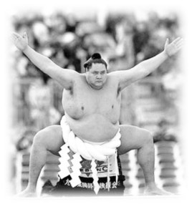**10. Shown here is a Sumo wrestler from Japan.**

**What could be his weight? A.** 50 kg

**B.** 150 kg

**C.** 750 kg

**D.** 1000 kg

**11. Mohita has a piece of thread. She knows how long the thread is. What can she find out using ONLY THE THREAD?**

**A.** How fast her friend is walking.

**B.** How far the two ends of a bench are.

**C.** The number of spokes in her bicycle wheel.

**D.** The time it takes to reach school from home.

**12. The time shown in the clock is .**

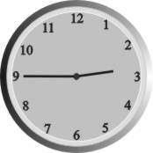

**A.** between 2 and 3 in the afternoon

**B.** between 9 and 10 in the morning

**C.** between 2 and 3 in the afternoon or in the night

**D.** between 9 and 10 in the afternoon or in the night